1. Set Up Azure Resources

* Screenshot of the Azure portal displaying the creation of the resource group for the PetStoreApp.

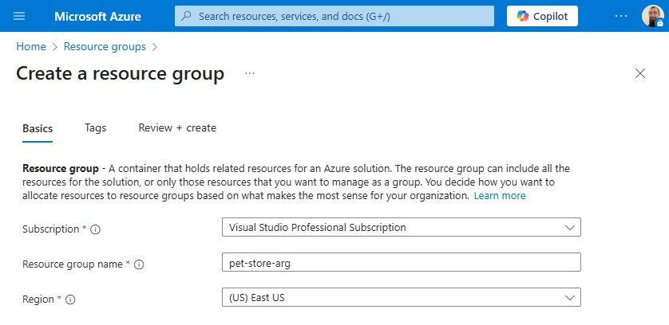

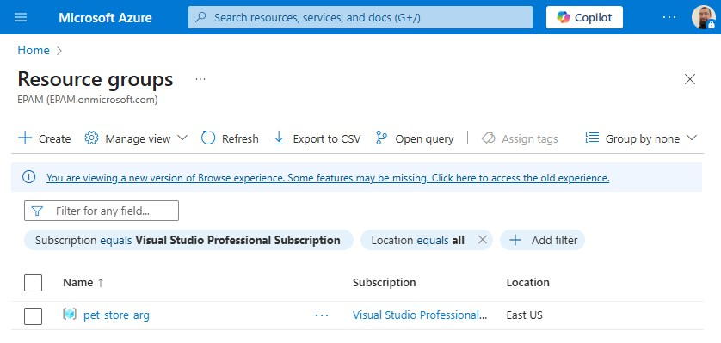

* Screenshot of the successful creation of the Azure Container Registry (ACR).

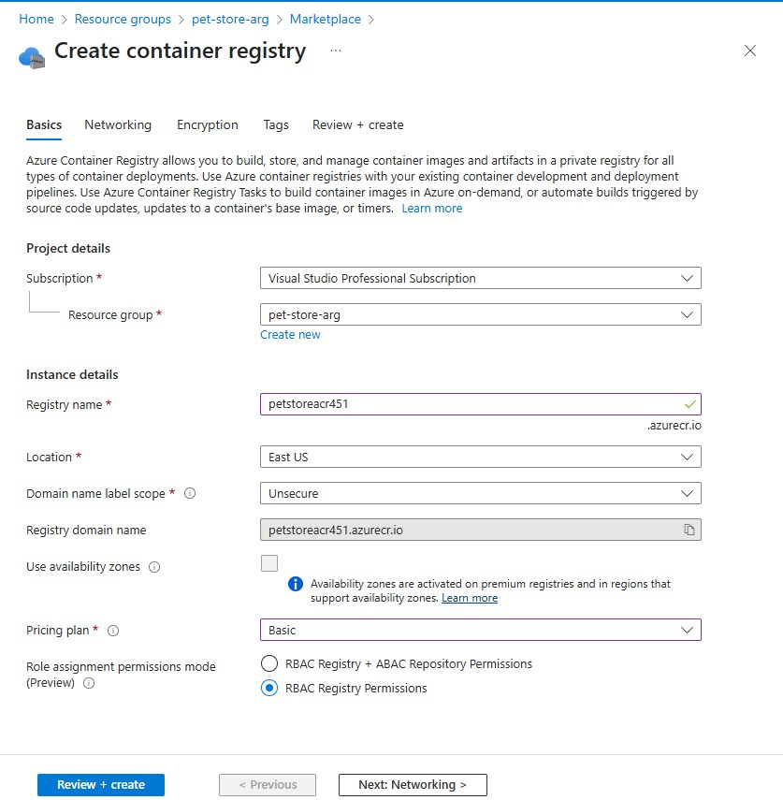

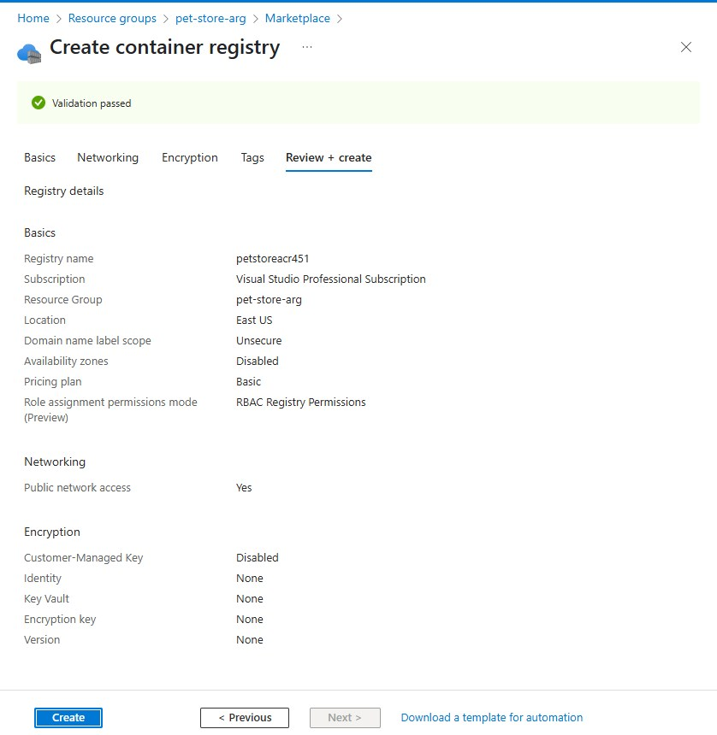

* Screenshots documenting the Docker image build and push process to the ACR.

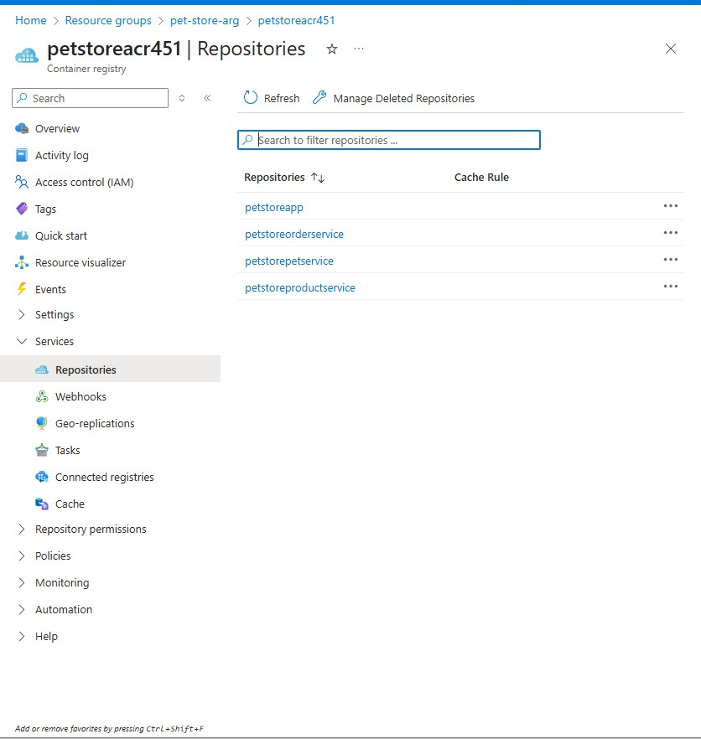

1. Deploy Services to Azure App Services

* Creation of App Service Plans for PetStoreApp (Web) and Public API Services.

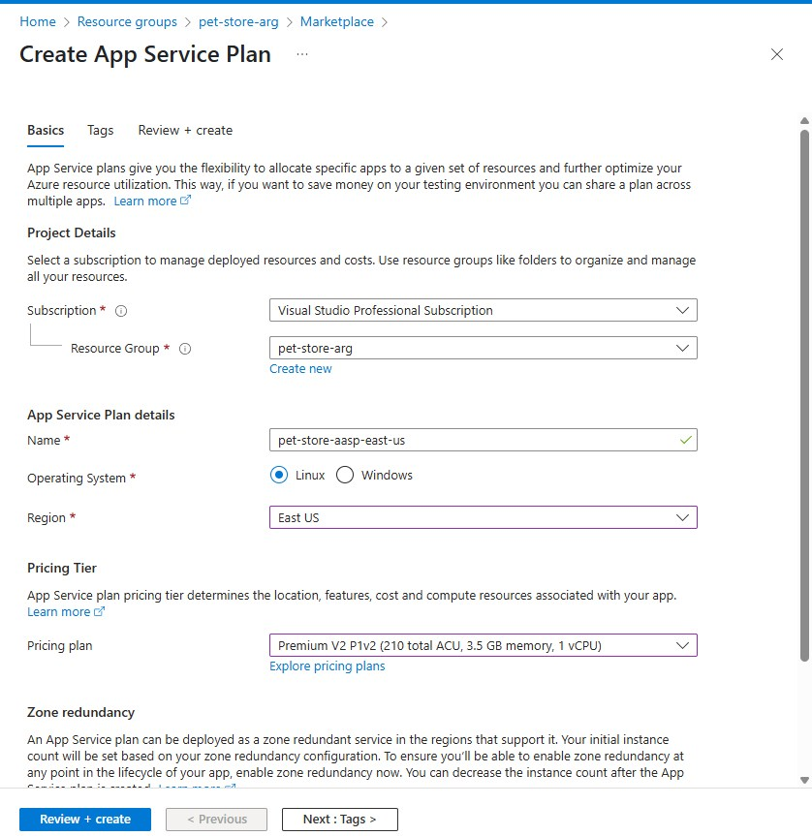

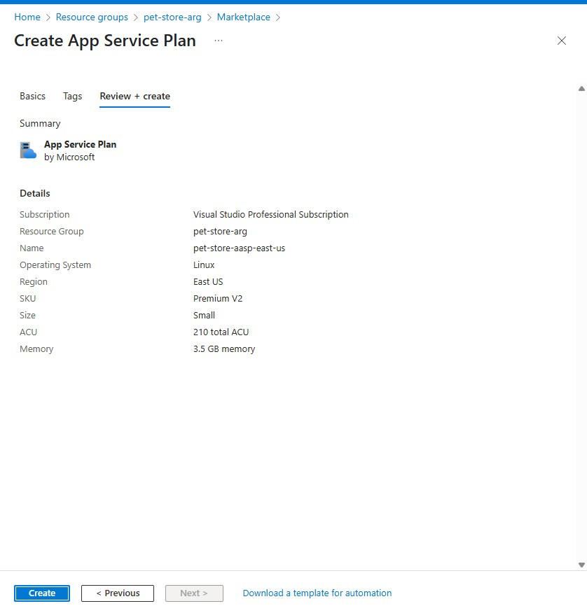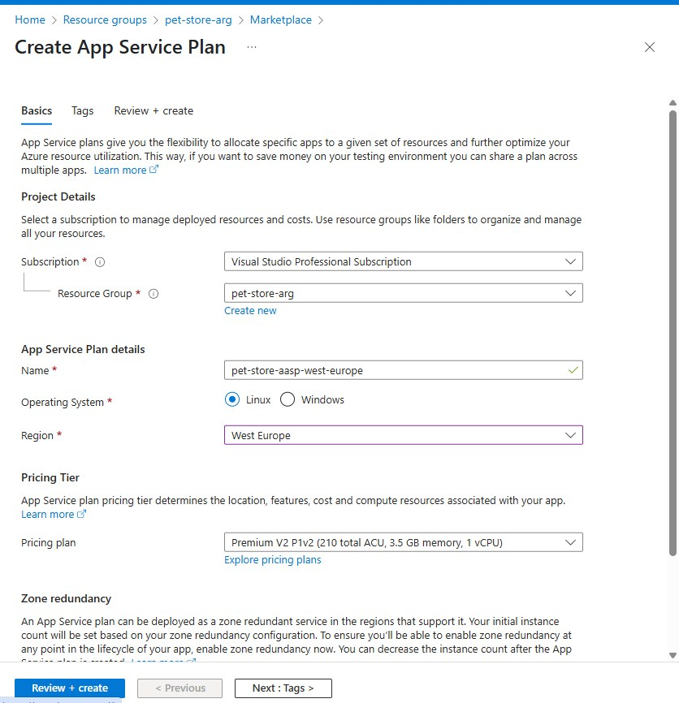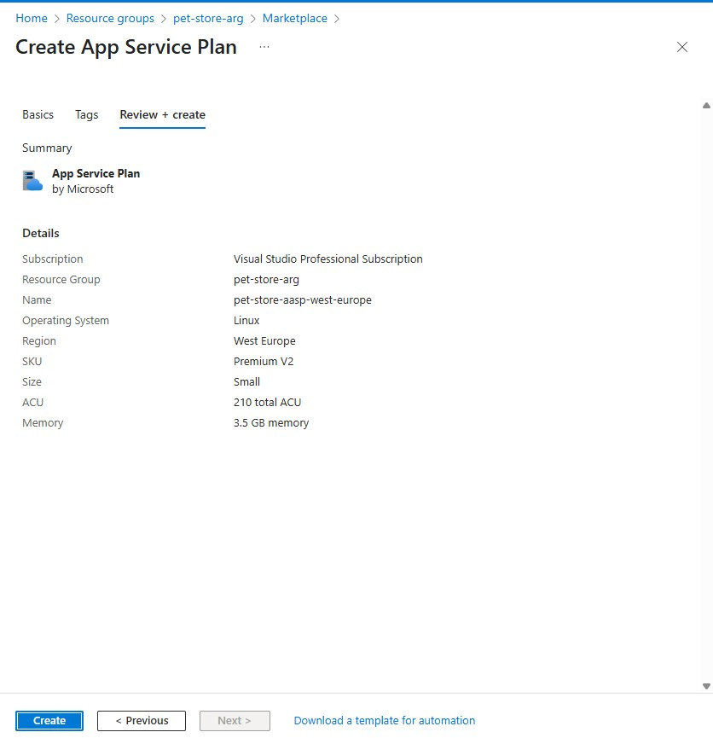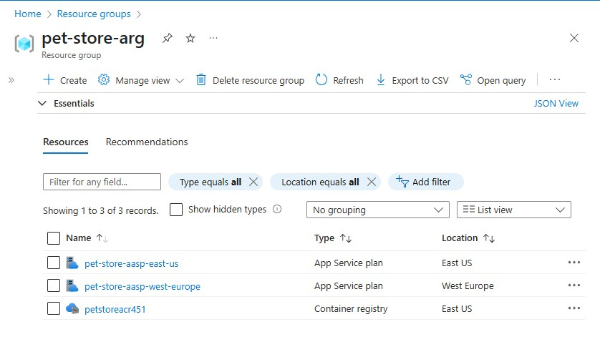

* Deployment of PetStoreApp (Web) to two different regions.

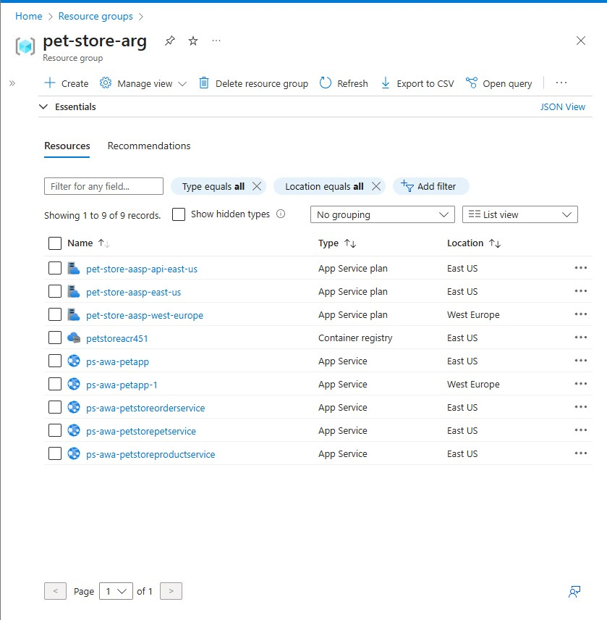

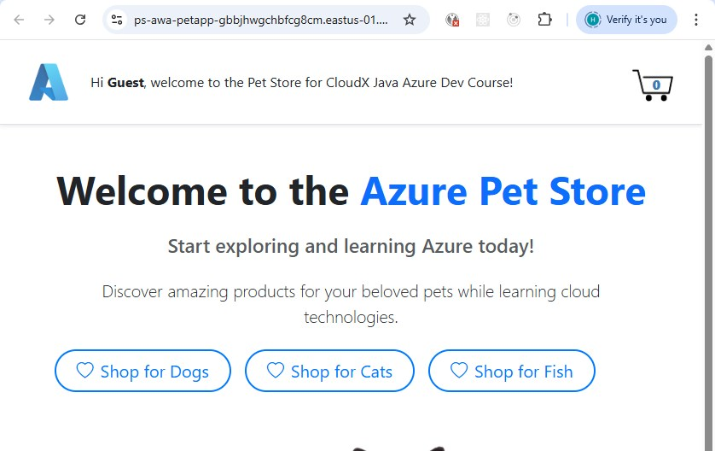

* Configuration of environment variables for services communication.

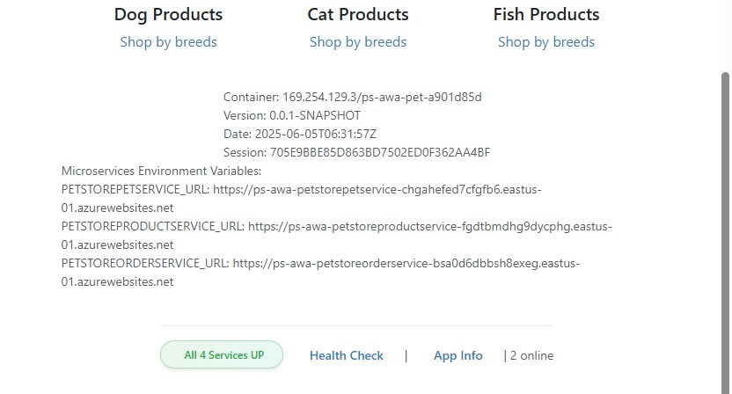

* Successful navigation between pages without errors.

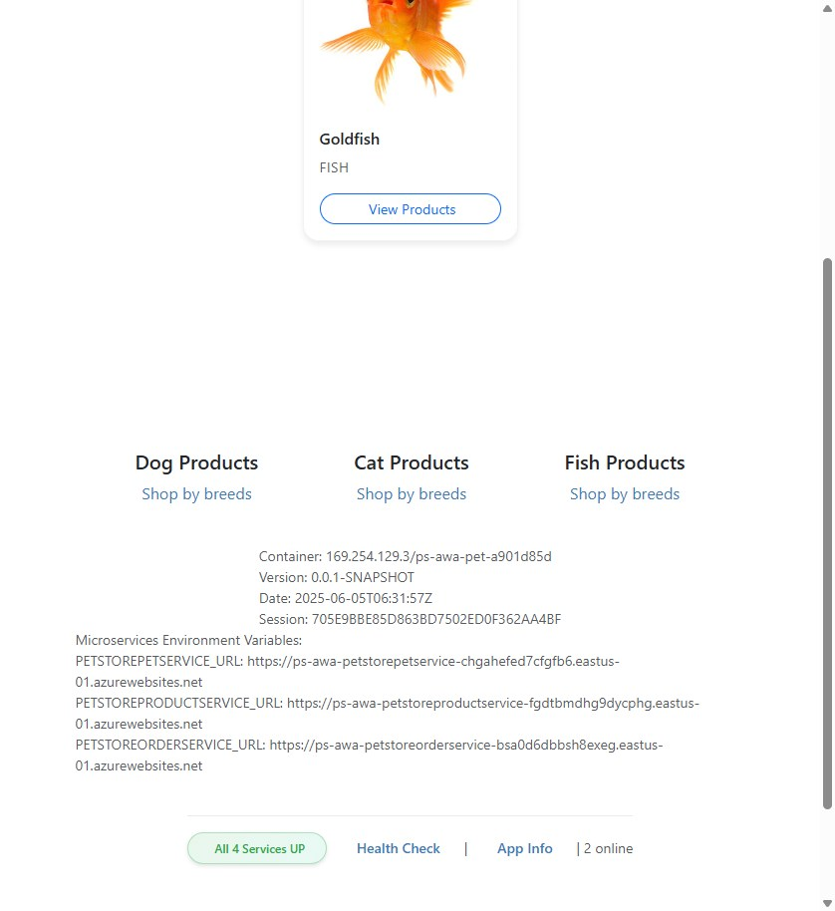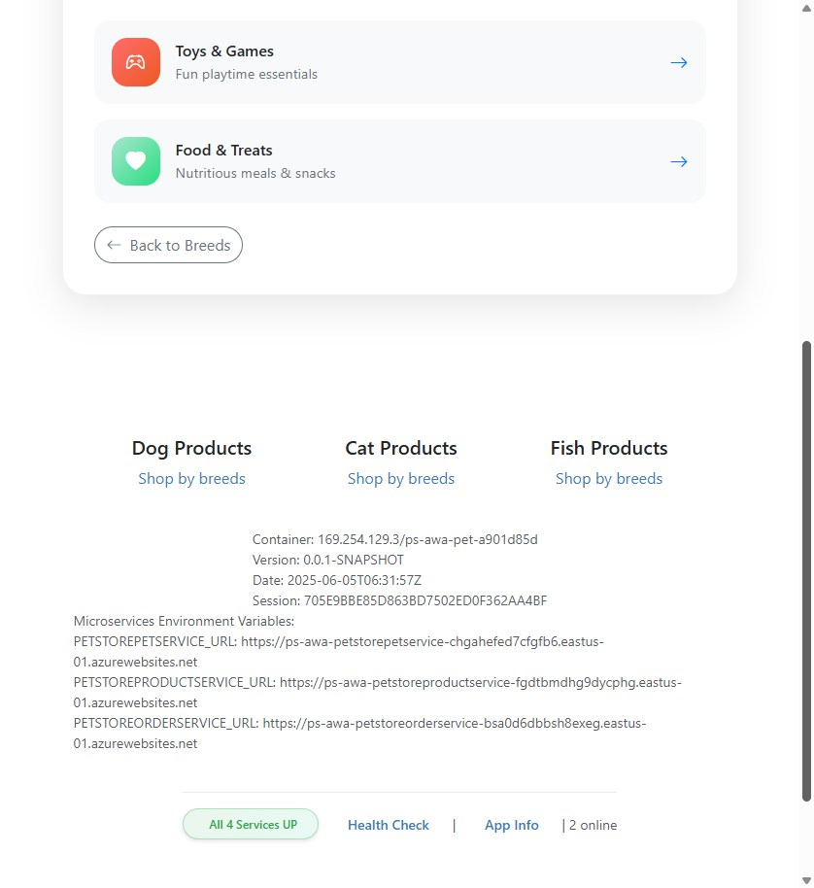

1. Configure Auto-Scaling

* Configuration of rules-based autoscaling for public API services.

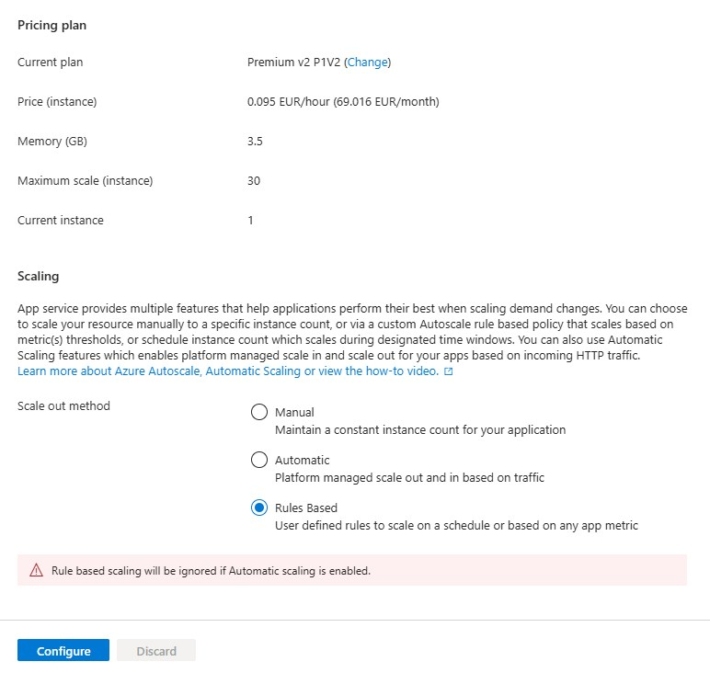

* Setup of custom autoscale settings, including CPU usage thresholds.

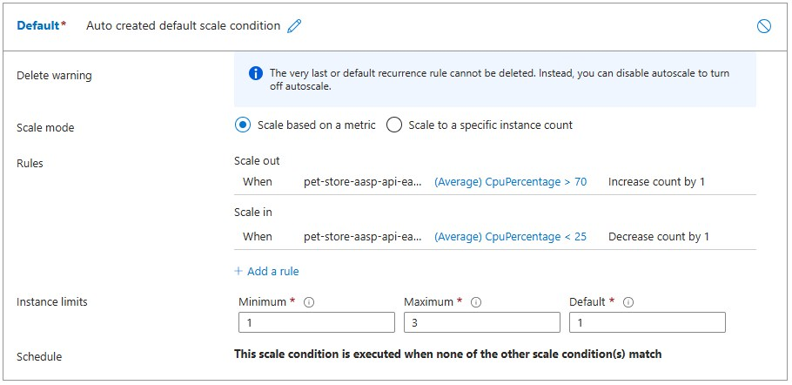

* Verification of autoscaling settings and rules.

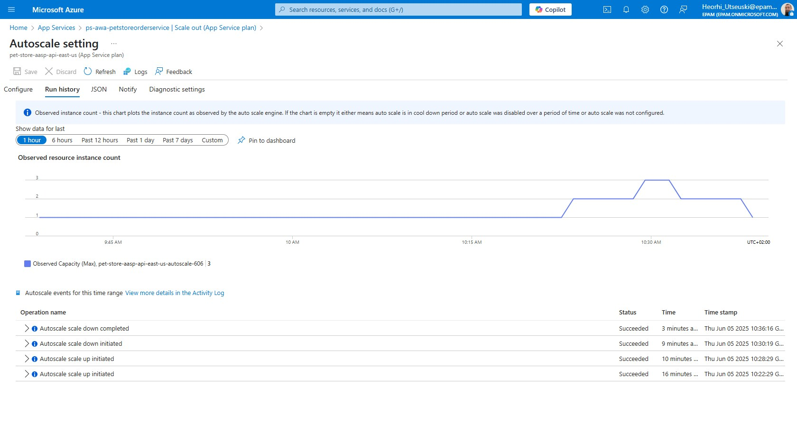

1. Test Autoscaling using k6 Tool

* Swagger endpoints utilized for testing autoscaling.

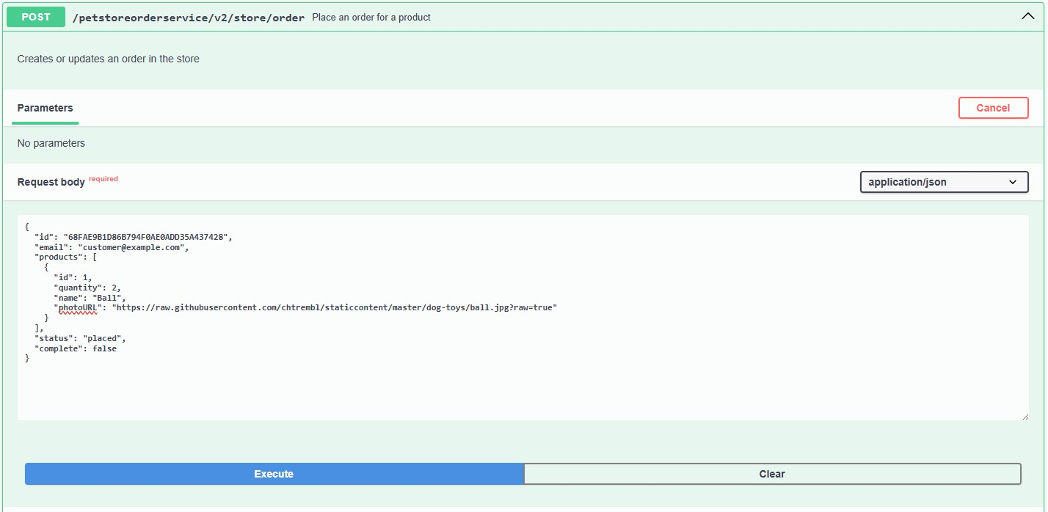

* k6 tool in use for testing autoscaling.

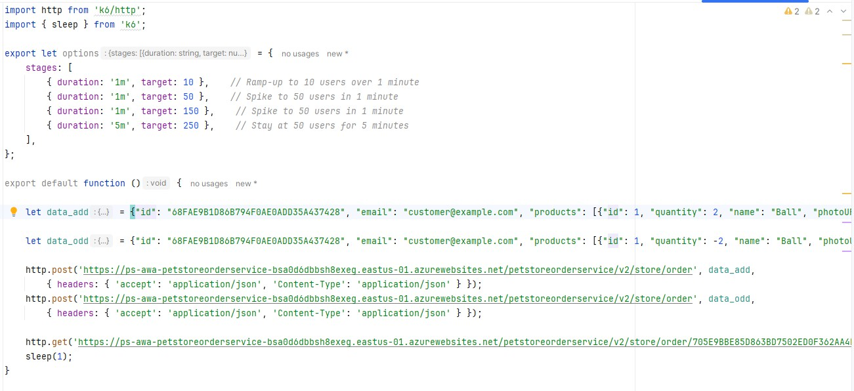

* Results, particularly showing the scaling behavior under load.

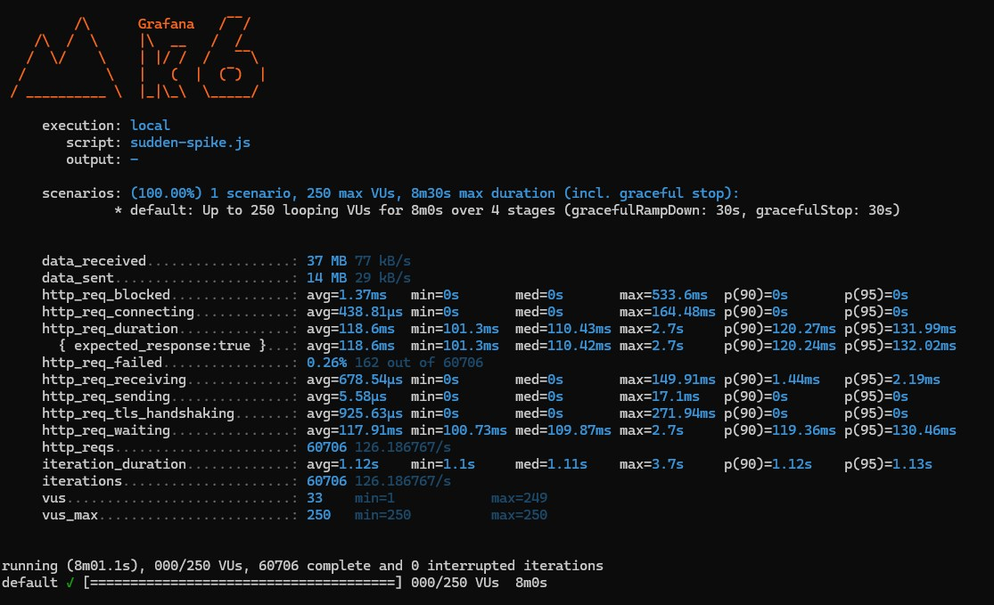

1. Set Up Deployment Slots for PetStoreApp

* Creation of a deployment slot for PetStoreApp.

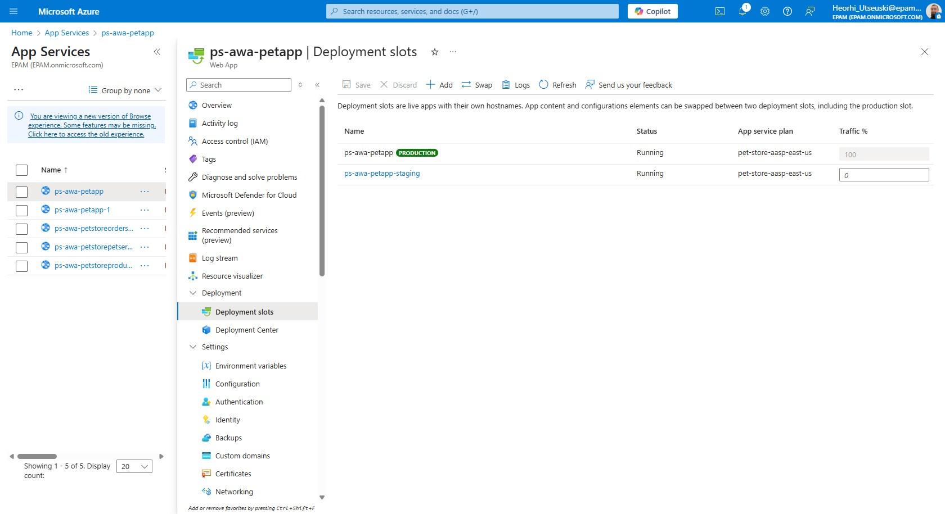

* Configuration of slot settings, including continuous deployment.

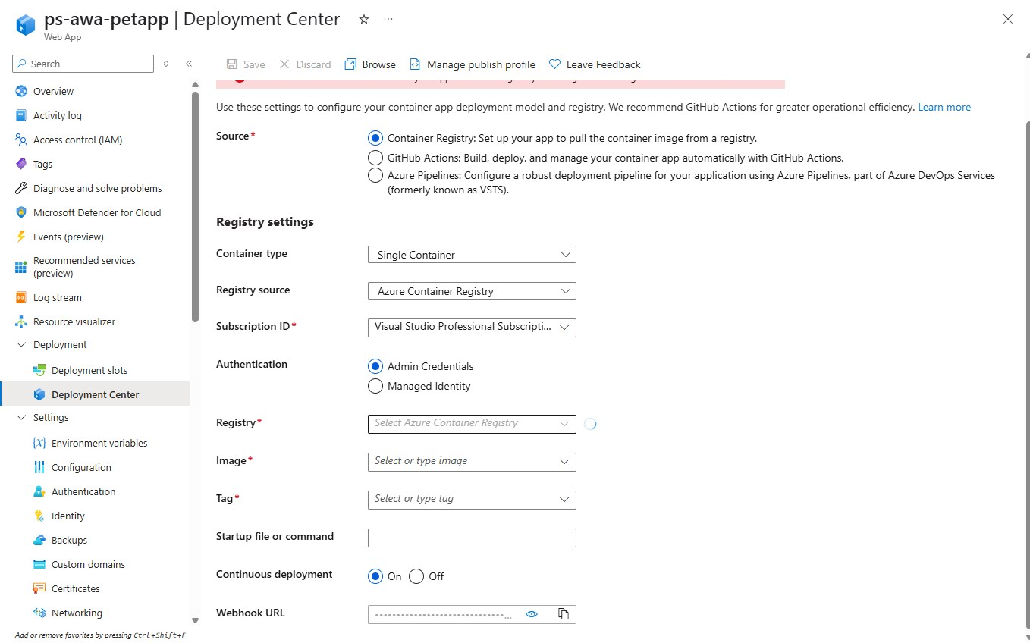

* Successful push of an updated Docker image to the Azure Container Registry.

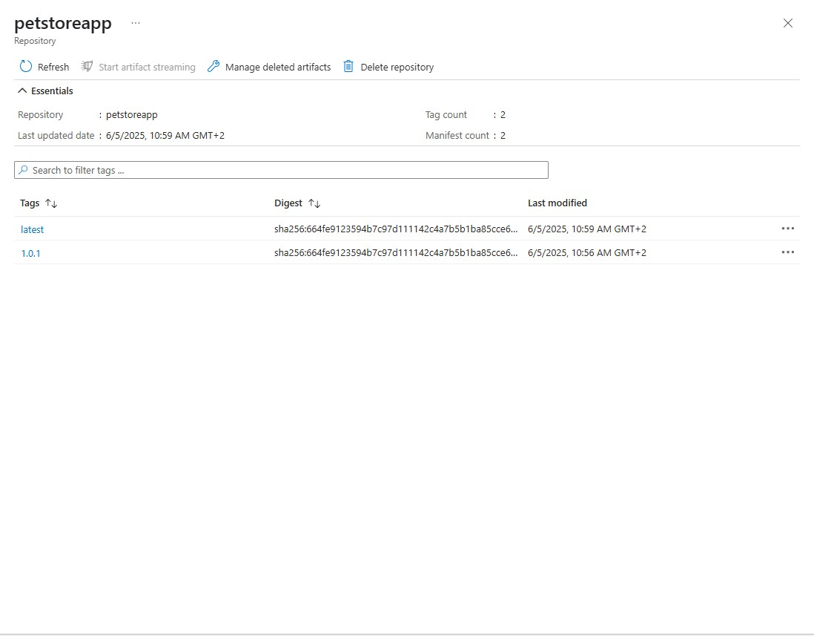

* Testing of the deployment slot and verification of changes.

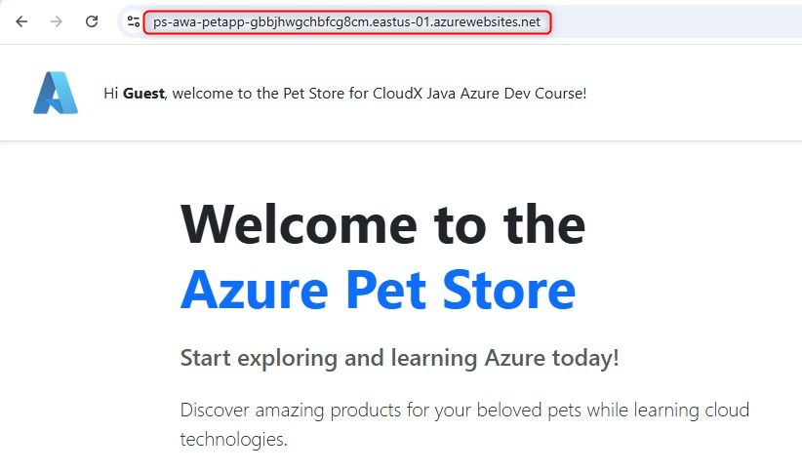

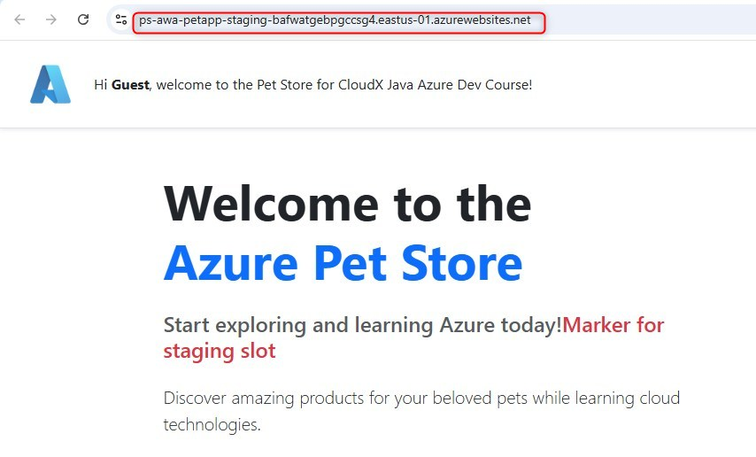

* Screenshot of initiating the slot swap process.

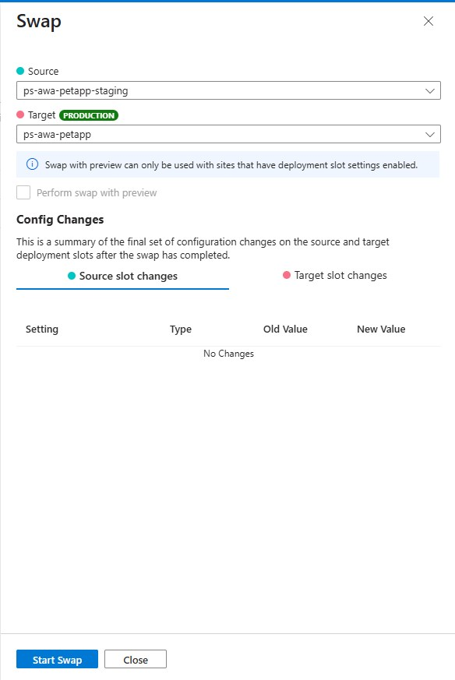

1. Configure Traffic Manager

* Creation of a Traffic Manager profile.

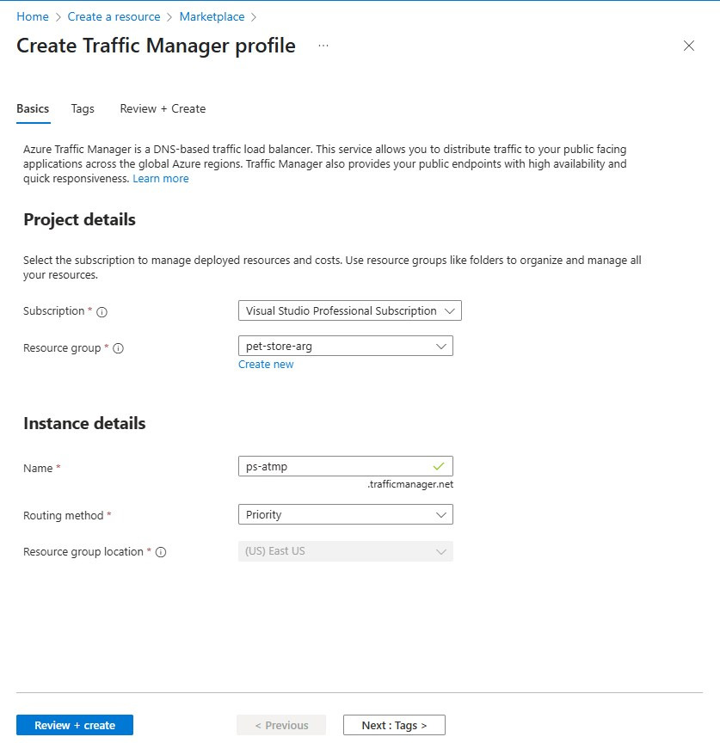

* Addition of endpoints representing different PetStoreApp instances.

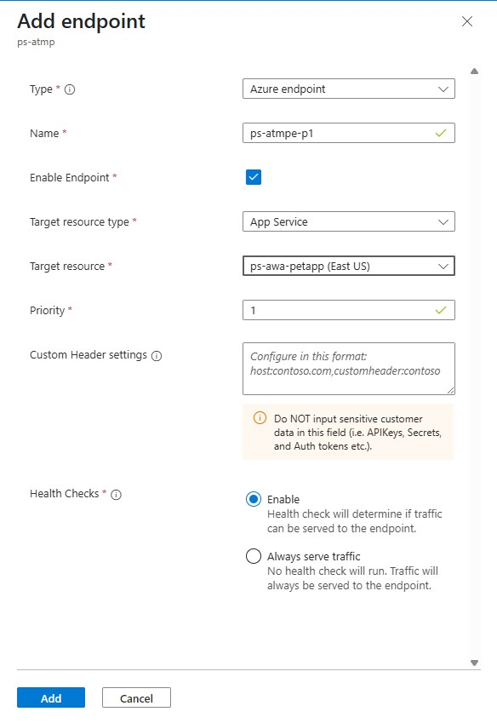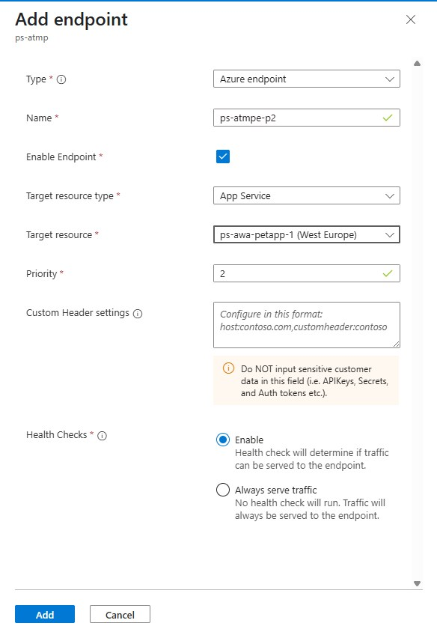

* Use of Traffic Manager URL to access the application.

